Name: Hovan Hodges
Course: CST-305
Assignment Name: Project 4 - Degradation of Data Integrity
Date: 5/31/2026

Responsibilities and completed tasks by each team member
I completed all tasks as I worked on this by myself.
Specific problem solved
The specific problem addressed is modeling and visualizing the degradation of data stored on a digital medium (specifically, NAND flash memory) over time. In digital storage, data integrity is not strictly permanent; it slowly degrades due to natural quantum leakage, which is significantly accelerated by environmental factors like thermal stress, repeated program/erase cycles (wear), and radiation. By mathematically defining these degradation factors, we can predict when the electrical charge within memory cells will drop below the hardware's critical read threshold, causing binary bit-flips, and resulting in data corruption, such as the progressive visual degradation of a stored image.
The mathematical approach for solving it
The mathematical approach for solving the specific problem above involves modeling the data degradation as a system of coupled ODEs. Let x_{i}(t) represent the normalized electrical charge of the i-th memory cell. The continuous rate of charge loss for the entire storage block is defined by the system:
$$x^{'}\left(t\right)=A\left(t\right)x\left(t\right)+x\left(t\right)$$
The diagonal matrix elements a_{ii}(t) encapsulate the time-dependent internal decay rates, dynamically scaled to reflect increased leakage due to thermal spikes relative to ambient temperature (T_{op}(t) - T_{amb}) and cumulative structural wear. The external forcing vector f(t) accounts for sudden, stochastic charge depletion events, such as alpha particle strikes. This continuous state vector x(t) is evaluated against a fixed threshold to determine binary bit-flips, allowing us to quantify the exact data corruption using the Mean Squared Error (MSE) between the original and degraded data.
The approach for implementation in code
The approach for implementation in code relies on numerical integration to solve the ODE system over a defined time span. Using Python and scientific computing libraries, specifically scipy.integrate.solve_ivp, we evaluate the continuous charge state of each pixel's underlying memory cell at targeted time intervals. Inside the ODE function, environmental variables like temperature and wear are dynamically calculated at each time step to construct the decay matrix, while pseudo-random arrays simulate unpredictable radiation events. Once the solver returns the array of charge values across the time span, a boolean mask is applied to check which specific cells have fallen below the 0.5 hardware read threshold. This step translates the continuous physical decay into discrete digital bit-flips, allowing graphics packages like matplotlib to visually render the progressively corrupted stages of the image.

Screenshots depicting key phases in the program execution
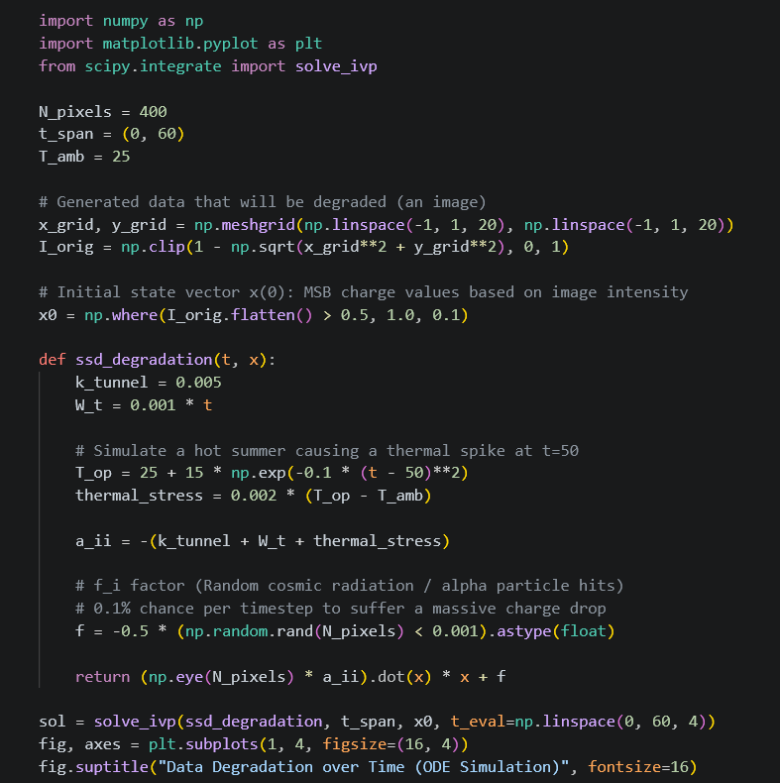
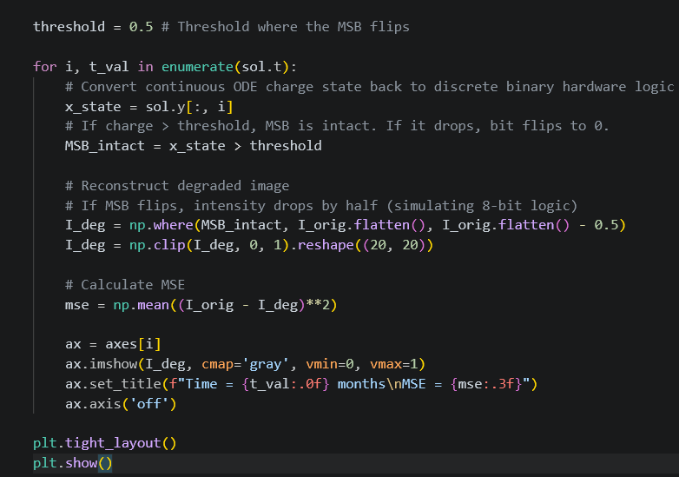

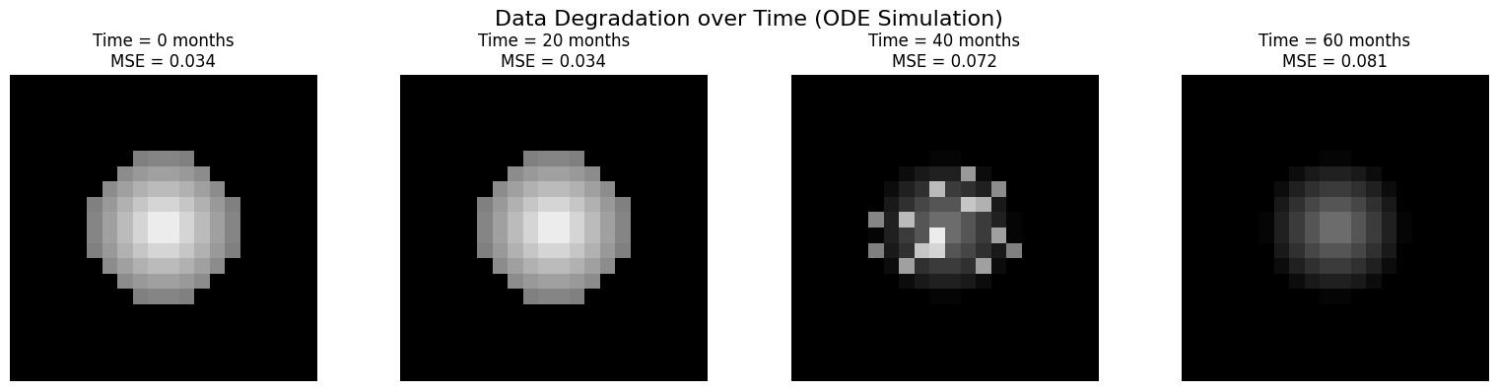
References for theory and code sources
- Google’s Gemini
- Instructor Kiju Kim’s presentation slides
README document written in Markdown, detailing how to install and run the program
The README.md document is posted within the Github and was uploaded alongside this PDF document inside Halo Learn.

